**AWS EKS Kubernetes - Masterclass**

<https://github.com/stacksimplify/aws-eks-kubernetes-masterclass>

**Docker Fundamentals**

<https://github.com/stacksimplify/docker-fundamentals>

**Kubernetes Fundamentals**

<https://github.com/stacksimplify/kubernetes-fundamentals>

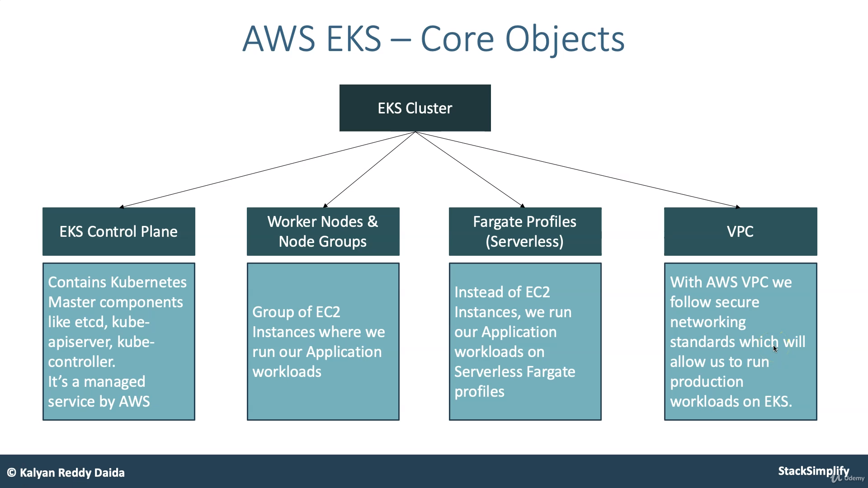

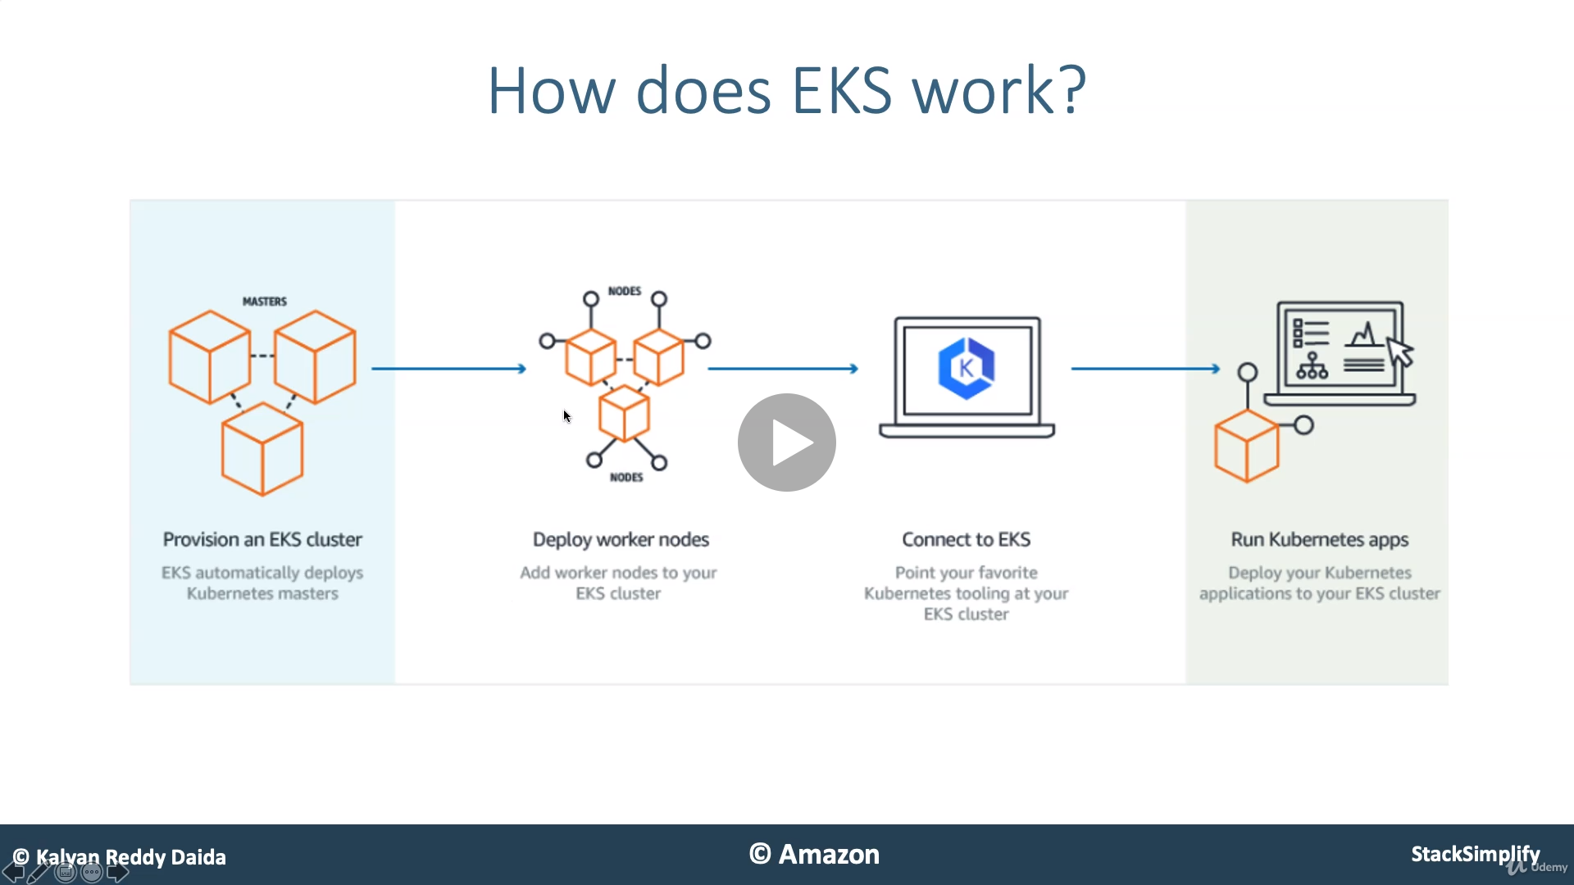

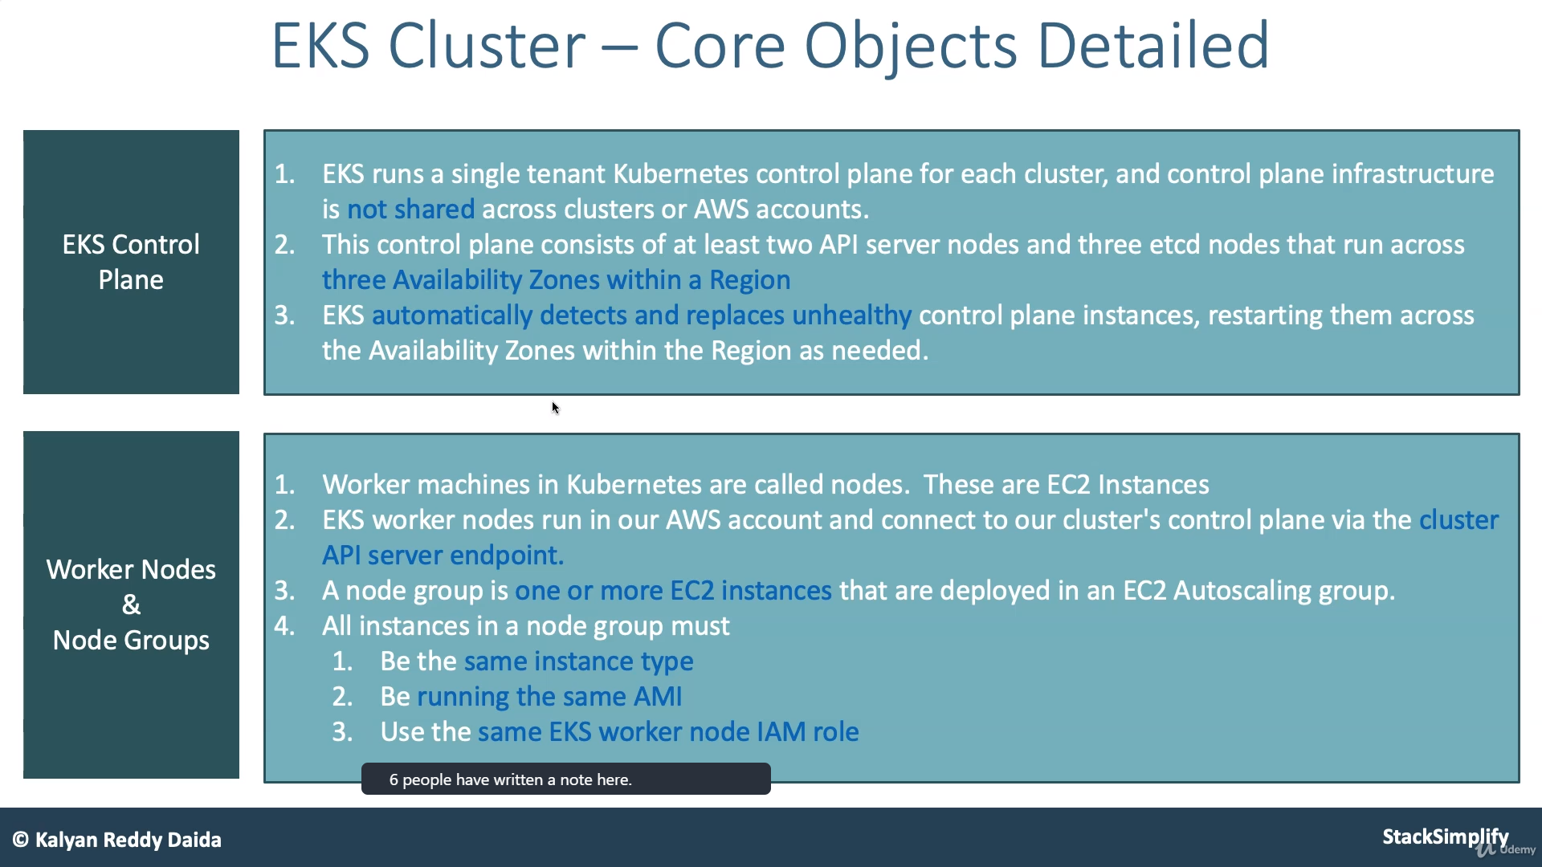

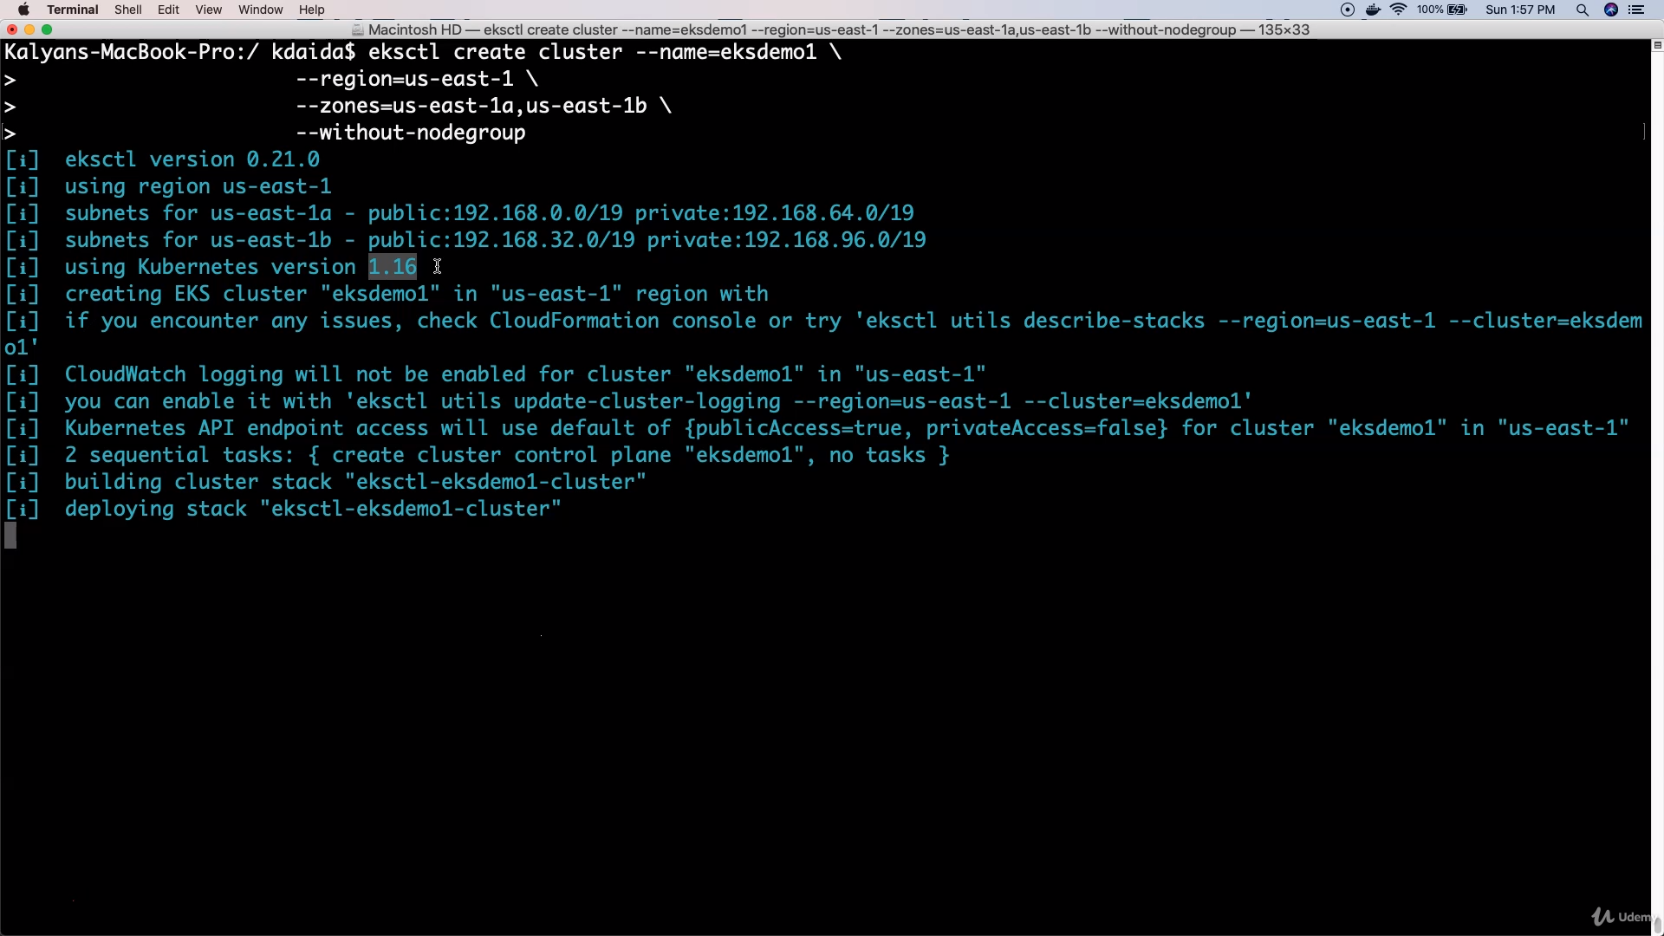

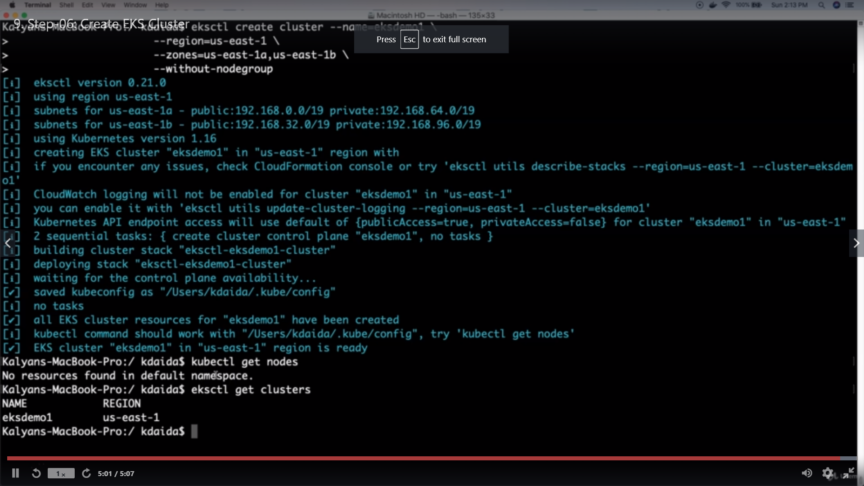

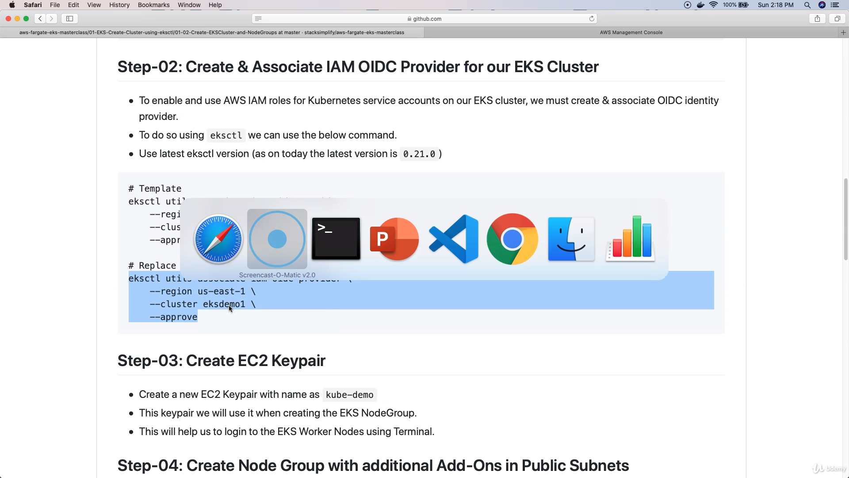

<https://github.com/lvcanil84/aws-eks-kubernetes-masterclass/tree/master/01-EKS-Create-Cluster-using-eksctl/01-02-Create-EKSCluster-and-NodeGroups>

